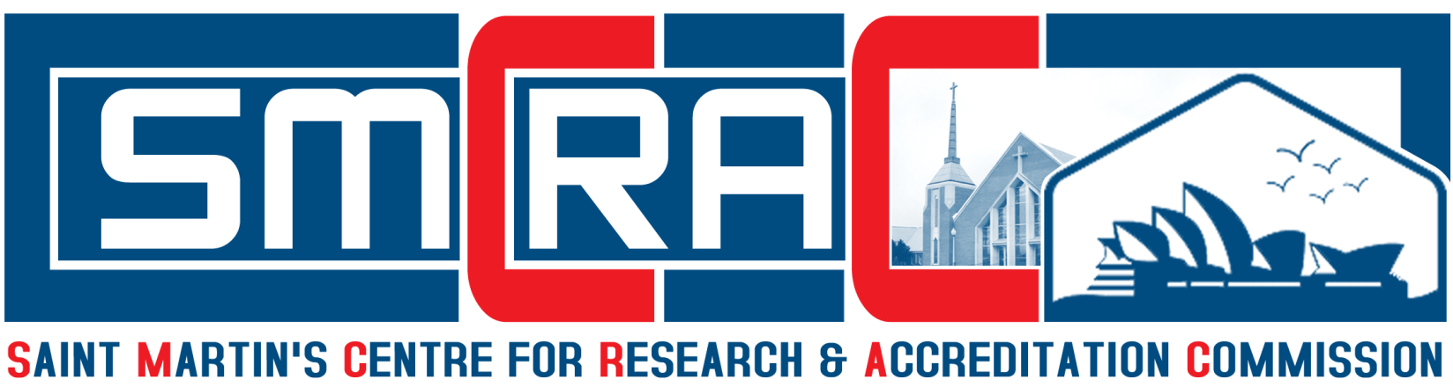
Office: Unit 22, 71-109 Bourke Road, Clarinda, Victoria, Melbourne - 3169, Australia
Website: www.smcrac.org Email: office@smcrac.org

GLOBAL PROFESSIONALS – EDUCATIONALIST AWARDS & HONORS CONVOCATION

Saint Martin’s Centre for Research & Accreditation Commission (SMCRAC) will be celebrated on every year at Australia / United States of America / India. The Awards will be present to the Winners by the Board of Directors of SMCRAC Australia / United States of America / Indian Chapter. Please submit the filled application in word, pdf (or) scan format via email to: Email: smcracoffice@gmail.com

Name of the Category
Name of the Applicant
Gender
Date of Birth
Place of Birth
Nationality
Citizenship
Mobile Numbers
Email Ids
Address for Communication
Permanent Address
Educational Qualification
Area of Specialization
Designation
Name of the Department
Official Address
Year of Completion of Ph.D
Ph.D Registration Number
Title of Ph.D Thesis
Name of the University
Name of the Supervisor
Teaching Experience
(in Years)
Full Time Research Experience
(in Years)
Industrial Experience
(in Years)
No. of Ph.D Scholars Awarded
No of Ph.D Scholars Doing
Patents (in Numbers)
Research Grants
(in Numbers)
Research Projects
(in Numbers)
SCI Journal Publications
(in Numbers)
Scopus Journal Publications
(in Numbers)
Other Journal Publications
(in Numbers)
International Conference Publications (in Numbers)
National Conference Publications (in Numbers)
International Conference Presentations (in Numbers)
National Conference Presentations (in Numbers)
International Books Publications
(in Numbers
National Books Publications
(in Numbers)
Chapters Publications
(in Numbers)
International Training Programs Attended (in Numbers)
Resource Talk (in Numbers)
International Awards Received
(in Numbers)
National Awards Received
(in Numbers
Editorial Appointments in International Journals (in Numbers)
Editorial Appointments in National Journals (in Numbers)
No. of MOU Signed
No. of Conference / Symposium / Training Programs Organized
No. of Participation in NSS / NCC / YRC/ CCC / Others
No. of Professional Societies Membership

Declaration: I certify that the above mentioned information is correct and complete to the best of my knowledge and trust. At any time I am found to have concealed / distorted any material information, my application shall be liable to be instantly terminated without notice / compensation.

Signature of Applicant

Date:
Place:
Award Categories:

- Best Researcher Award
- Best Research Scholar Award
- Best Senior Faculty Award
- Best Young Faculty Award
- Excellence Teaching in Higher Education Award
- Best Director of the Year Award
- Best Principal of the Year Award
- Best Dean of the Year Award
- Best Women Faculty Award
- Award of Excellence in Research
- Life Time Achievement Award
- Distinguished Professor Award
- Outstanding Achievement Award
- Outstanding Woman Award
- Young Engineer Award
- Senior Engineer Award
- Out Standing Engineer Award
- Young Scientist Award
- Senior Scientist Award
- Out Standing Scientist Award
- Young Researcher Award
- Senior Researcher Award
- Out Standing Researcher Award
- Innovative Academician Award
- Best Teacher Award
- Albert Einstein - Research Scientist Award
- Isaac Newton - Research Scientist Award
- William Shakespeare - Star Golden Award
- Certificate of Honorary Excellence Award
- International Noble Ambassador Award
- Person of the Year in (Your Specialization)
- International Prestigious Award
- International Star Excellence Award
- Goodwill Ambassador Award
- Embodiment of Personality Award
- International Golden Award
- Best Creator of the Year Award
- Star ICON Award
- The Great Personality Award
- International Leadership Award
- Exclusive Golden Award
- Best Educationist Award
- International Brand Icon Award
- Golden Apple Education Award
- Lord Buddha Golden Award
- The Super Hero Award
- International Golden Award
- International Nobel Award
- International Super Hero Award
- Best Humanitarian Award
- Mother Teresa Global Peace Award
- Moon Star Icon Award
- Best Social Activist Award
- World Top Leader Award
- International Brand Icon Award
- Legend of the World Award
- International Noble Ambassador Award
- Global Talent Icon Award
- The Pride of Nation Award
- Nelson Mandela International Peace Award
- International Prestigious Award
- Mahatma Gandhi Peace Award
- Mahatma Gandhi International Nobel Peace Award
- Dr. APJ Abdul Kalam Research Fellowship Award
- Dr. Sarvepalli Radhakrishnan Research Fellowship Award
- Rabindra Nath Tagore - Global Peace Award
- Swami Vivekananda - Global Peace Award
- Global Eminent Scientist Award
- Global Eminent Researcher Award
- Global Eminent Teacher Award
- Global Eminent Academician Award
- Global Eminent Industry Achiever Award
- Others……

